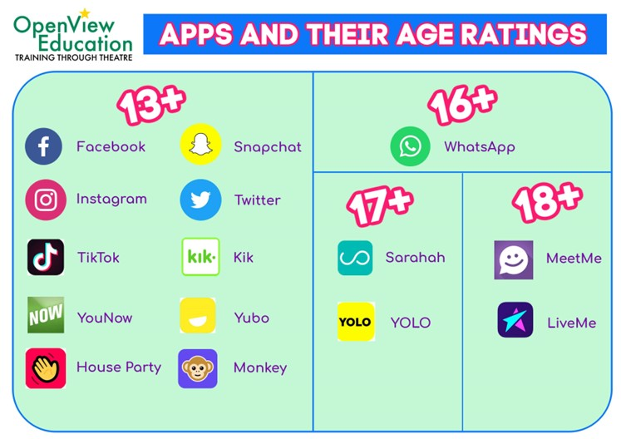

**Online Safety Tips for Parents**

Take an active interest in your child’s online world and explore what they can do in their different social media platforms. Learning together with your child can often open opportunities to discuss safe behaviour and provide them with an opportunity to share any concerns they may have.

Ask your child who they are playing with and find out if they are talking to other players; this could be strangers, friends or family members. Talk about what positive friendships and healthy relationships might look like online. Be mindful that being ‘friends’ on social media doesn’t automatically mean you can see exactly what your child is posting or what they are seeing online. Your accounts will have different algorithms (so you will see different suggested content and ads) and they may choose to limit whether you can see posts that they share.

**Learn together!**

* Make sure your child understands that their online actions and behaviours can have offline consequences.
* Discuss what your child believes is safe and acceptable for them to do online, then add your own limits. E.G. How long they are allowed to spend online or if they are allowed devices in their bedroom.
* Set clear boundaries about how to respond if they see something upsetting or if someone behaves or communicates inappropriately towards your child online.
* Be honest and transparent about how you are going to monitor their online activity to maintain a trusting relationship.
* Discuss and agree on age-appropriate ground rules for posting, sharing, and communicating with others on social media.
* If you share a device with your child, make sure purchase options are password protected and you log out of online banking or payment apps (such as PayPal) so children can’t inadvertently spend money without your knowledge.
* Encourage your child to use an appropriate screen/character name that follows the rules and does not reveal any personal information.
* Younger children may need simpler, stricter boundaries to keep them safe, such as “always being kind online”, whereas teens and older children may need discussions about trust, respect and healthy friendships.
* Together explore the safety features within their games and social media platforms; show them how to block and report other users and support them in taking some control over how people communicate with them online.

**Top Tips!**

Online Safety is an important part of safeguarding and keeping children safe at Hunton Primary School. We teach all pupils about safe and appropriate behaviour online as part of Computing and PSHE lessons, but we can only be successful in embedding this education if we work together with parents and carers to ensure that messages are consistent at home too.

Whilst for many children and adults, the internet is a valuable resource for information and entertainment, it is essential that children understand how to keep safe when using the internet. As a school, we do not advocate pupils using platforms under-age, however we acknowledge that many of them will be using these services (with parents’ permission), so we believe it is appropriate to focus on teaching them how to use it safely.

The age restriction to have an account on most social networking platforms is 13+.

When children use apps aimed at an older age group, they are likely to see content which is aimed at the age they signed up as, which may leave them vulnerable to being exposed to unsuitable content.

Many adults fall victim to financial scams online, so we shouldn’t be surprised that our children are also vulnerable to the deception and manipulation tactics used. Make the most of parental controls available! These can be available from your internet provider directly as well as through individual games. For example, many games, websites and apps let you block in-app purchases and report inappropriate adverts or scams.

No internet filters or parental controls can be 100% guaranteed to keep children safe online. There is always a potential that children may accidentally click on a link or share information that puts them at risk of financial harm, which is why it is important to discuss with them what to do if/when this happens.

Be mindful that children are naturally curious and push boundaries; they may actively try to find a way around the parental controls and filters you have in place. If your child has made a mistake, try to avoid shaming or blaming them as this can make it harder for children to be honest and tell us if/when things go wrong in the future.

**Be realistic…**

**Age restrictions**

**Content**

Being exposed to illegal, inappropriate, or harmful content, for example: pornography, fake news, racism, misogyny, self-harm, suicide, anti-Semitism, radicalisation, and extremism

**Commerce**

Risks such as online gambling, inappropriate advertising, phishing and or financial scams.bullying.

The breadth of issues classified within online safety is considerable and ever-evolving however, they can be categorised into four areas of risk:

**Contact**

Being subjected to harmful online interaction with other users; for example: peer to peer pressure, commercial advertising and adults posing as children or young adults with the intention to groom or exploit them for sexual, criminal, financial or other purposes.

**Conduct**

Online behaviour that increases the likelihood of, or causes, harm; for example, making, sending and receiving explicit images e.g. consensual and non-consensual sharing of nudes and semi-nudes and/or pornography, sharing other explicit images and online bullying.

**For more information and advice about keeping children safe online, visit the following websites:**

[Online safety teaching resources | Internet Matters](https://www.internetmatters.org/schools-esafety/)

https://www.childnet.com

[Keeping children safe online | NSPCC](https://www.nspcc.org.uk/keeping-children-safe/online-safety/)

<https://saferinternet.org.uk>

[CEOP Education (thinkuknow.co.uk)](https://www.thinkuknow.co.uk/)

[www.getsafeonline.org](http://www.getsafeonline.org/)